**Object model:**

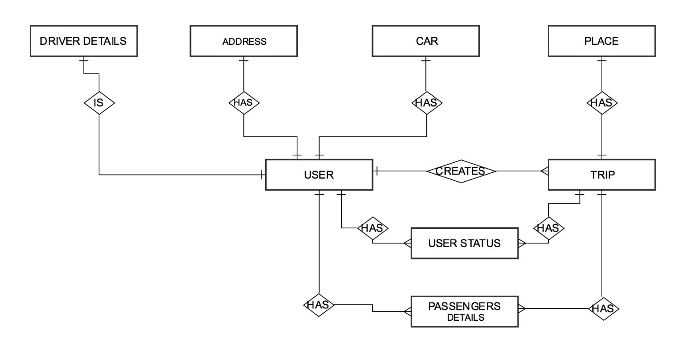

**Entities in the application are as follows:**

1. **User:** It will contain the details about the user. A user can be a driver or a passenger in carpool. As a driver a user can create a trip and post its details. A passenger will view a post and add himself in a trip as long as there is a vacancy in the trip. The passenger’s request to join the trip will be accepted or rejected by the driver.
2. **Driver_details:** It will contain the details of the driver such as the license no, its validity etc.
3. **Car:** This entity will have a one to one mapping with the user and will contain details pertaining to the user’s car.
4. **Address:** This entity is a property of the user and will store the user’s address.
5. **Passenger_details:** Will contain the details about the trip of individual passengers.
6. **Trip:** It will contain the details about a particular trip like its start location and its destination, its distance, cost of the trip etc.
7. **Place:** Will store all the locations which will be used by other entities.
8. **User status:** will contain the status of the request of a user for a particular trip.

**Roles in the application are as follows:**

1. Admin: the admin will be able to remove a user and monitor the entire application.
2. User: The entire application revolves mainly around the user. The user can be a driver or a passenger.

**Business Idea:**

I am developing a carpooling application where users (driver) will be able to share their cars with other users (passengers) who are looking to travel to the same locations. This will help in help to reduce the travel cost of both the driver and passengers and also provide an opportunity to meet with new people.